Hannah Stark Press Kit
Author of Trucker and Train (Clarion Books/HMH Kids, August 2019)

Email: Hannahcarinastark@gmail.com
Webpage: https://www.hannahcarinastark.com/
Twitter: https://twitter.com/hannahstarknyc
Instagram: https://www.instagram.com/teachingrightalong/

Publicity

Kirkus
“Grab your CB radios and hold onto your whistle. In this battle of truck vs. train, the true winners are the readers.”

School Library Journal
“The relationship between the trucker and other vehicles illustrates the complex dynamic of jealousy, admiration, and friendship among peers. A wonderful and fun addition to any library collection.”

Bio

Hannah Stark grew up watching her mom, Marisabina Russo, create picture books in her studio. She remembers a house filled with children's books as well as bags of teaching materials since her father was a teacher. Today Hannah's home is filled with picture books and teaching materials, too. Hannah has been teaching elementary school in the New York City Public Schools for fifteen years. She loves making and sharing resources for other educators and teaching kids to write. She was inspired to write her debut book, TRUCKER AND TRAIN, while playing with her son. When not writing or teaching, Hannah can be found taking road trips and train rides to unfamiliar places.

Places to Purchase and Review
Amazon
https://www.amazon.com/dp/0544801814/ref=cm_sw_em_r_mt_dp_U_0UPxDb1P3D9FT

Indie Bound
https://www.indiebound.org/book/9780544801813

Barnes and Noble
https://www.barnesandnoble.com/w/trucker-and-train-hannah-stark/1129078033?ean=9780544801813

Target
https://www.target.com/p/trucker-and-train-by-hannah-stark-hardcover/-/A-76390250

Walmart
https://www.walmart.com/ip/Trucker-and-Train-9780544801813/420591335

Author Photo 1 (credit TM Davy)

Author Photo 2 (credit Natasha Stanglmayr)

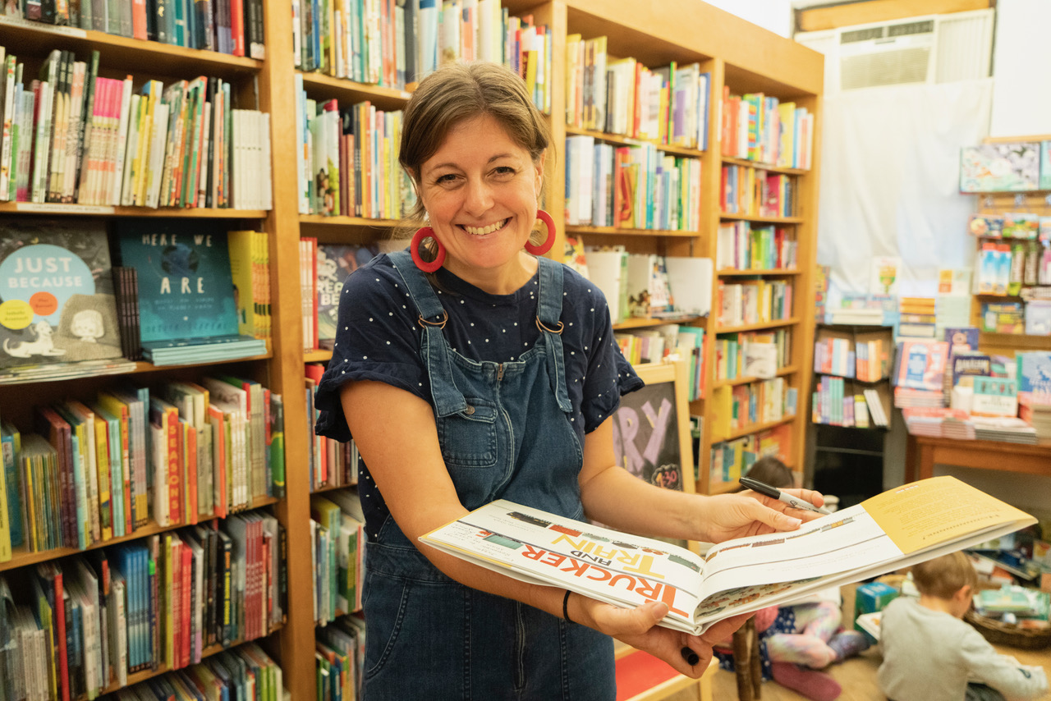

Trucker and Train Cover Image

